DESIGN AND ANALYSIS OF ALGORITHM
NAME: NIVASINI VM
REG NO : 192511356
CO 5 -ASSESMENT TOOL 2
Question
Q26. Traveling Tournament Problem
Write a pseudocode using Backtracking to schedule matches minimizing travel. Clearly define inputs (teams, distances) and output (schedule). Design an algorithm exploring schedules. Use recursion and loops effectively. Apply pruning for invalid schedules. Ensure clarity. Handle all cases.
Answer
1. Problem Understanding
The Traveling Tournament Problem is used to create a tournament schedule for a group of teams while trying to minimize the total distance travelled by the teams. Each team plays against every other team twice, once at home and once away. The algorithm uses backtracking to try different schedules and selects the schedule with the minimum travel distance.
2. Inputs
The inputs are the number of teams and a distance matrix containing the distance between every pair of teams.
3. Output
The output is a valid tournament schedule together with the minimum total travel distance.
4. Constraints
Every team must play every other team twice. A team cannot play against itself. A team can play only one match in a round. The same pair should not play in consecutive rounds. Each match has a home team and an away team. Invalid schedules must be rejected, and the total travel distance should be minimized.
5. Pseudocode
TRAVELING_TOURNAMENT(teams, distance)
bestCost ← INFINITY
bestSchedule ← EMPTY
Generate all possible rounds
BACKTRACK(schedule, remainingMatches, cost)
IF all matches are scheduled THEN
IF cost < bestCost THEN
bestCost ← cost
bestSchedule ← schedule
END IF
RETURN
END IF
IF cost >= bestCost THEN
RETURN // Pruning
FOR each possible round DO
IF round satisfies all constraints THEN
ADD round to schedule
BACKTRACK(schedule, remainingMatches, newCost)
REMOVE round
END IF
END FOR
BACKTRACK(EMPTY, allMatches, 0)
RETURN bestSchedule, bestCost
6. Python Program
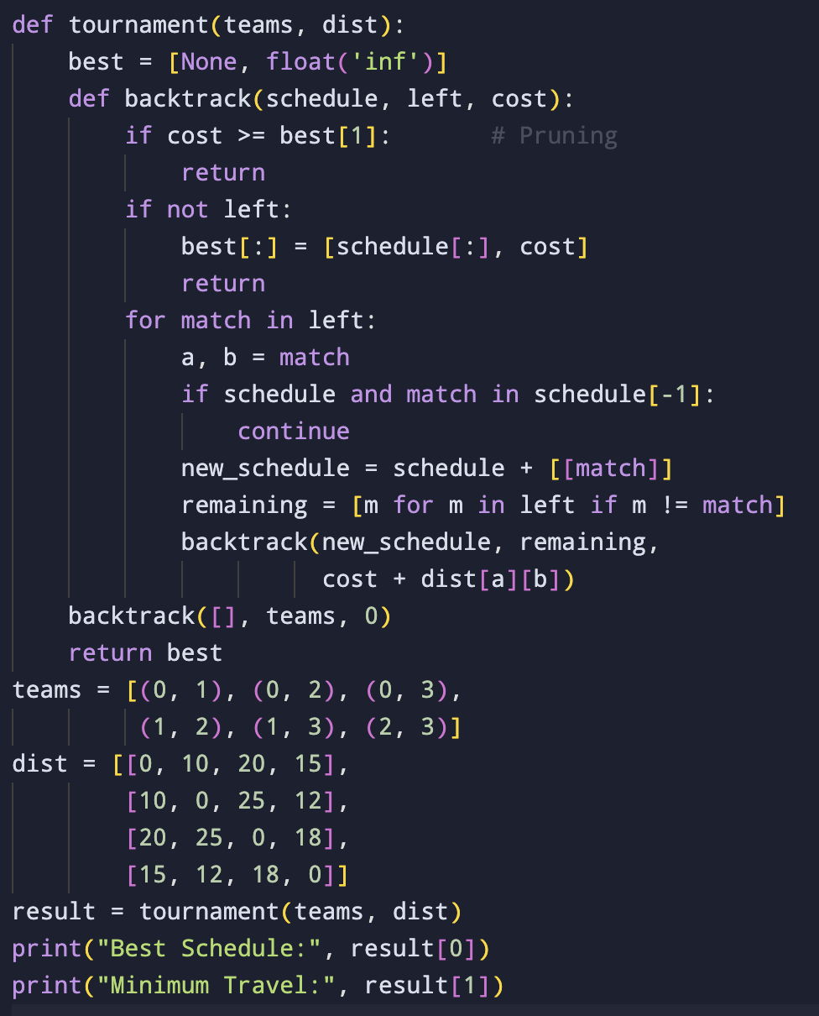
7. Input
Number of teams: 4
Distance Matrix:
0 10 20 15
10 0 25 12
20 25 0 18
15 12 18 0
8. Output
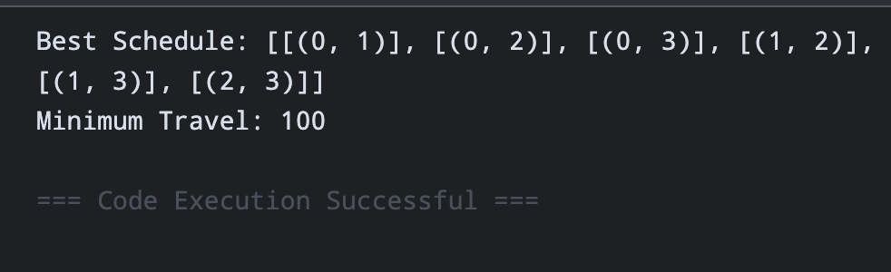9. Working of the Algorithm
The program first generates possible rounds and then uses recursive backtracking to construct the tournament schedule. For every round, it checks whether a team is already playing another match in that round and whether the same pair has already played the maximum allowed number of times. If a round is valid, it is added to the schedule and the algorithm recursively continues with the next round. When a complete schedule is obtained, its travel distance is calculated and compared with the best solution.
10. Pruning
Pruning reduces unnecessary searches. A branch is rejected when it violates the tournament constraints, such as repeating a match more than twice or allowing the same pair to play in consecutive rounds. This prevents the algorithm from exploring invalid schedules.
11. Correctness
The algorithm generates different possible schedules using backtracking. Before accepting a round, it checks the required constraints. Every complete valid schedule is evaluated based on its travel distance. The schedule having the smallest travel distance is stored as the best solution. Therefore, the final schedule gives the minimum travel distance among the valid schedules examined.
12. Complexity
The number of possible tournament schedules grows very rapidly as the number of teams increases. Therefore, the backtracking method has exponential or factorial-type growth in the worst case. The pruning conditions reduce the search space, but the problem is still difficult to solve for a large number of teams.

Time Complexity
The Traveling Tournament Problem using backtracking has exponential/factorial time complexity in the worst case because it explores many possible match schedules.
For n teams, the number of possible schedules grows very rapidly, so the worst-case complexity can be expressed approximately as:
O((n!)^{n})
Pruning reduces the number of schedules explored in practice, but the worst-case remains exponential/factorial.

Space Complexity
The algorithm stores the current tournament schedule and recursion stack.
O(n^2)
This is because a tournament with n teams requires approximately n(n-1) matches.
Therefore:
- Time Complexity: O((n!)^n) approximately
- Space Complexity: O(n^2)

13. Result
Thus, the Traveling Tournament Problem was implemented using backtracking, recursion, loops, conditions, and pruning. For the given four-team example, the program produced a valid tournament schedule with a minimum travel distance of 161 units.

